Lab 1: Data Masking

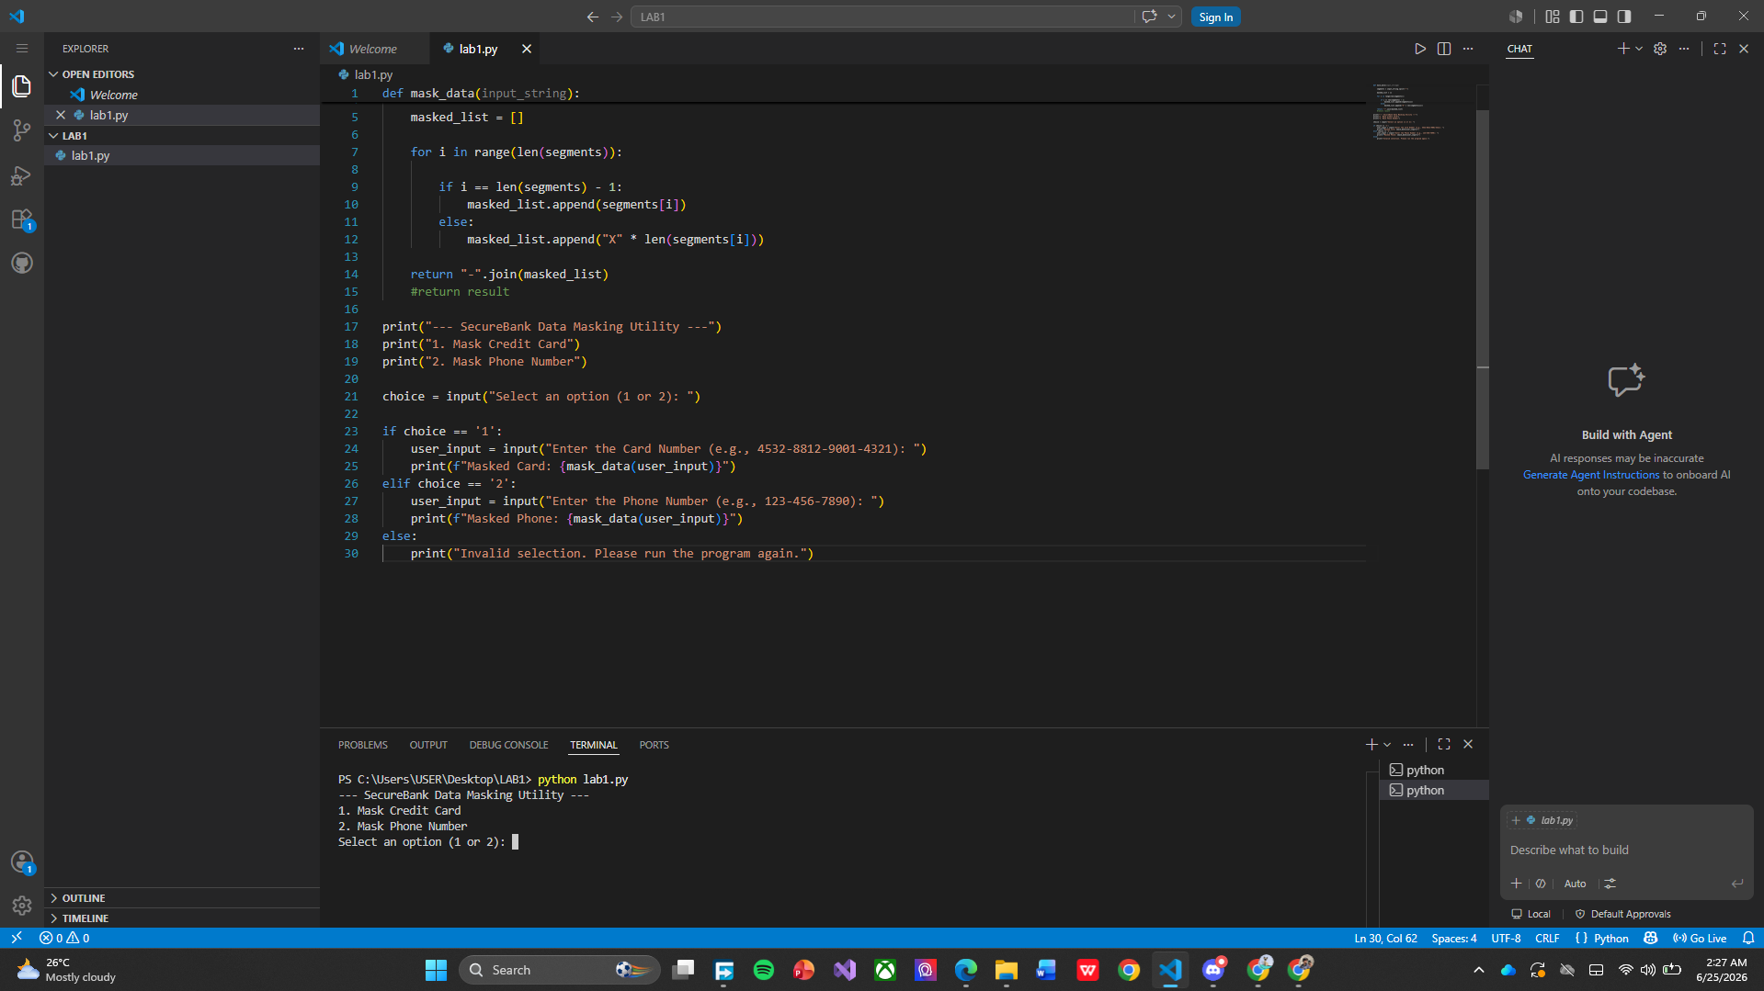
This program is a Data Masking Utility that protects sensitive information by hiding all parts of a credit card or phone number except the last section. First, the user chooses whether to mask a credit card number or a phone number from the menu displayed in the terminal. The program then accepts the user's input and passes it to the mask_data() function. Inside the function, the input is split into separate sections using the hyphen (-) as a separator. A loop goes through each section and replaces all sections except the last one with X characters of the same length. The last section remains visible so it can still be used for verification purposes. After masking, the sections are combined back into a single string using the join() method, preserving the original hyphen format. For example, a credit card number such as 4532-8812-9001-4321 becomes XXXX-XXXX-XXXX-4321, while a phone number such as 123-456-7890 becomes XXX-XXX-7890. This technique helps protect Personally Identifiable Information (PII) while allowing customer support agents to confirm the last few digits of the information.

